## UML Diagrams

### UML Use Case Diagram

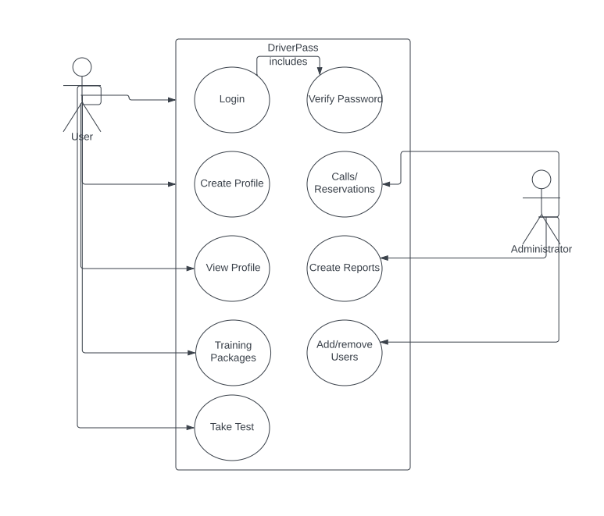

### UML Activity Diagrams

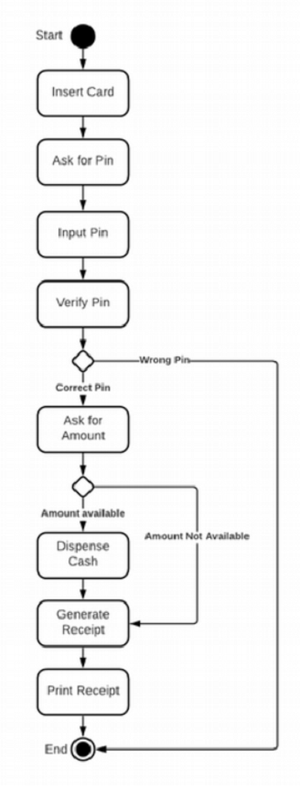

### UML Sequence Diagram

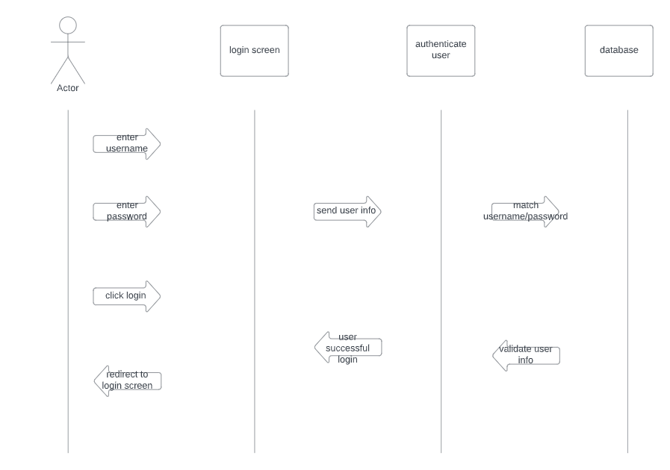

### UML Class Diagram

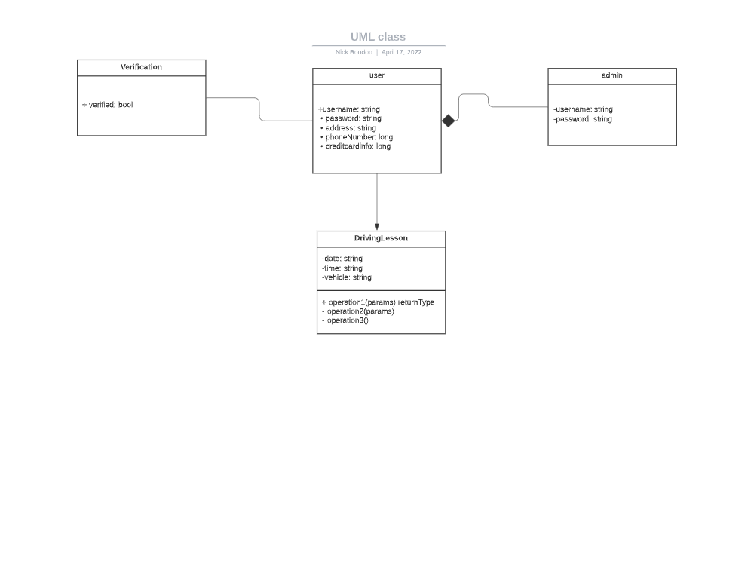

## Technical Requirements

The DriverPass application will be a web based application. This application will be based on the Python programming language since it will be very easy to work with cloud storage and hosting services. The cloud hosting service will be responsible for holding the database for our user information.